**Instagram User Analytics**

**A) Marketing Analysis:**

1. **Loyal User Reward:** The marketing team wants to reward the most loyal users, i.e., those who have been using the platform for the longest time.  
   Your Task: Identify the five oldest users on Instagram from the provided database.

1. **Inactive User Engagement:** The team wants to encourage inactive users to start posting by sending them promotional emails.  
   Your Task: Identify users who have never posted a single photo on Instagram.

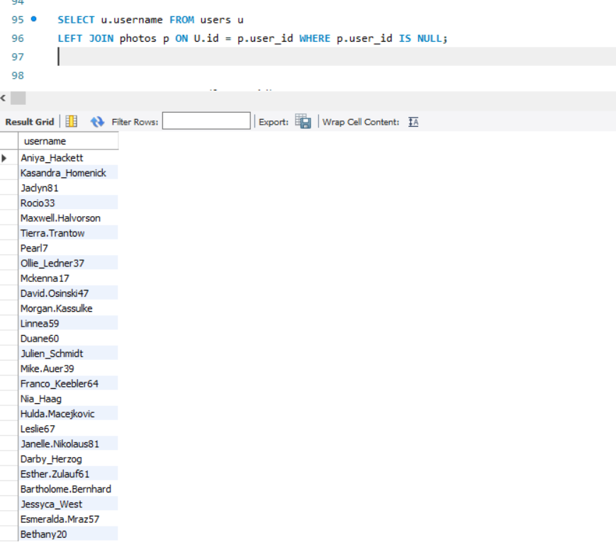

1. **Contest Winner Declaration:** The team has organized a contest where the user with the most likes on a single photo wins.  
   Your Task: Determine the winner of the contest and provide their details to the team.

1. **Hashtag Research:** A partner brand wants to know the most popular hashtags to use in their posts to reach the most people.  
   Your Task: Identify and suggest the top five most commonly used hashtags on the platform.

1. **Campaign Launch:** The team wants to know the best day of the week to launch ads.  
   Your Task: Determine the day of the week when most users register on Instagram. Provide insights on when to schedule an ad campaign.

**B) Investor Metrics:**

1. **User Engagement:** Investors want to know if users are still active and posting on Instagram or if they are making fewer posts.  
   Your Task: Calculate the average number of posts per user on Instagram. Also, provide the total number of photos on Instagram divided by the total number of users.

1. **Bots & Fake Accounts:** Investors want to know if the platform is crowded with fake and dummy accounts.  
   Your Task: Identify users (potential bots) who have liked every single photo on the site, as this is not typically possible for a normal user.

OR

